Asynchronous Rust

**Why Async?**

Async programming is the method to run parallel operation in our application. The nature of your application, web-server, database, or an OS, using the asynchronous programming you can get most out of the primary hardware. In Asynchronous Rust Programming, it allow us to run multiple operation simultaneously on the same OS thread. Asynchronous programming run multiple of these operation computation at the same time on a single thread.

**Example:**

Async code allow to multiple task simultaneously on the same OS thread if you want to download two different webpages at the same time .you spread the works across the two different threads.

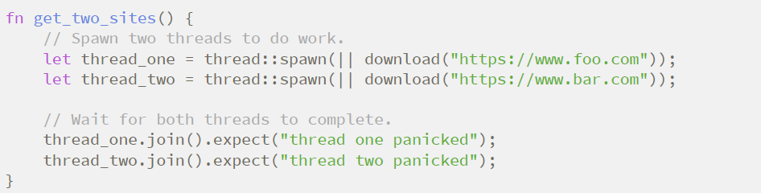

It might be works fine but for the heavy application work it doesn’t support because some limitation in Async rust we used Rust async/.await notation which allow us to run multiple task at once without creating multiple thread

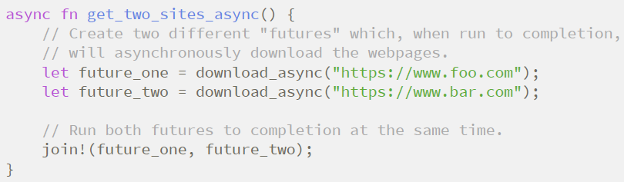

Async Rust has potential to be much faster and use less resources than a corresponding thread implementation. Thread are natively supported by the operating system and using them doesnot require any special programming model any function can create a thread and calling a function that uses thread is usually just as easy as calling any normal function.

**The State of Asynchronous Rust:**

The asynchronous rust ecosystem has undergone a lot of working/innovation over a period of time. The developer work hard to develop asynchronous Rust ecosystem strong. The future trait inside the standard library and the async/await language feature has recently been stabilized.